Scope
This policy defines the requirements for backup of information, software and systems.
Responsibility and Authority
The Group IT Manager is responsible for the overall management of this policy including its correct implementation and regular review.
Control and Distribution
This policy is issued as a controlled document and can only be updated by the authorised information management representative and must include a revision status and traceability of the change process.
A master is retained as part of the information security management system with uncontrolled copies issued at point of use.
Backup Policy
Back-ups are taken for different types of servers see table below, by a product called Backup Exec. Daily checks for successful back-up are done by IT which is recorded within the helpdesk and if a back-up fails it is highlighted in the back-up sever logs and actioned by IT.
Some areas of the fileservers use shadow copy to enable quick recovery of changed / deleted documents. The snapshots for these are done once in a morning and once in afternoon. This also helps mitigate some threats for Malware attacks.
Vm-ware (virtual server environment) is also backed up via replication of server to offsite location by use of Vsphere replication see below example.
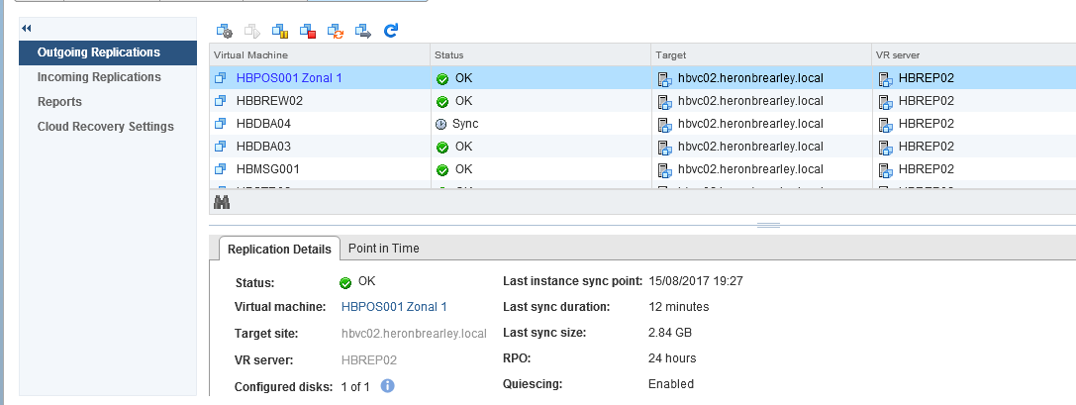

Protection of backup data has the same controls as our equipment siting process:
- Equipment should be sited to minimise unnecessary access into work areas.
- Servers & Network communications are secured within an access controlled server room with only authorised user access.
- PC and Printer are secured by departmental access controlled doors.
- Building services are controlled by the visitor control procedures and access control.

- Equipment is protected against environmental threats by siting in conditioned office space.
An example: Servers are protected by a controlled server room with environment monitoring and fire suppression, which will alert via email on abnormal conditions.
Datacentre racks are protected by logical and physical access controls provided by the 3rd party.
Table of Backups
Servers and data are also replicated to an offsite location to help enable business continuity plans.

Restoration is split into a number of areas of risk to the business:
Minor
Minimal impact to business operations i.e. corrupt file.
A file corruption example maybe restored via shadow copies of file data.
Medium
Disruption to the business operations, requiring a more in-depth restoration.
i.e. A malware infection where shadow copies could not restore the information.
High
Major disruption with the potential to invoke a business recovery plan.
i.e. server failure or disaster recovery.
Testing of restoration process is based on business requests for restoration of data which is then recorded within our helpdesk to with the completed action and time to restore.

