Removable Media Policy

PC’s which are resident members of the active directory domain have security settings in place via Group policy to disable access to removable media ports such as DVD/CD , USB and floppy disks.

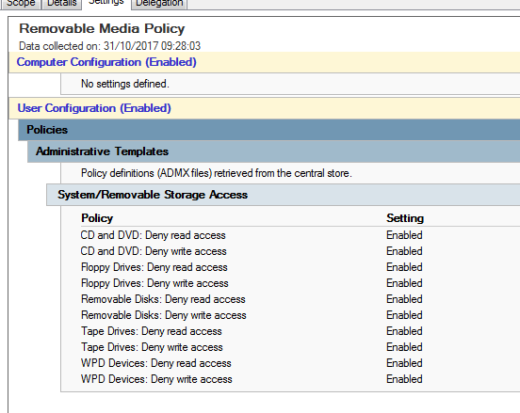

Users who require removable media will need to request files via the IT department who will scan any external device e.g. USB for viruses and then copy required files.

Only Authorised data should be taken off-site in accordance with data security rules.

Helpdesk records should be held for requests for data inbound and outbound via removable media.

